 | SIMATS ENGINEERING  Department of Computer Science and Engineering  CSA15 Cloud Computing and Big Data Analytics  CO2 AT2 - AI-Powered Big Data Analytics on Cloud Platform  Guided practical workbook for Azure VM, local VM, Docker container, security checks, recovery evidence and GitHub submission
Assessment Metadata
Course Code | CSA1517
Course Title | Cloud Computing and Big Data Analytics
Assessment | CO2 AT2 AI-Powered Big Data Analytics on Cloud Platform
Submission Type | Individual digital workbook based on the same capstone title used in CO1 and CO2 AT1
Faculty | Dr C. Rajesh Babu
Employee ID | SSETSCS415
Submission Mode | Completed workbook, evidence screenshots and GitHub repository link through Google Classroom
How This Workbook Works
- Use the same capstone title carried from CO1 and CO2 AT1.
- Read each procedure block, perform the action, verify the checkpoint and then fill the response table.
- Use Azure first when account activation is available. Use the local VM path when Azure is blocked. Use Docker for container comparison. Use simulation only when practical deployment is blocked.
- Screenshots must show the student's actual configuration or verified simulation work. Hide credentials, keys, tokens and sensitive account details.
- Upload the completed workbook and evidence to GitHub, then submit the GitHub repository link through Google Classroom.
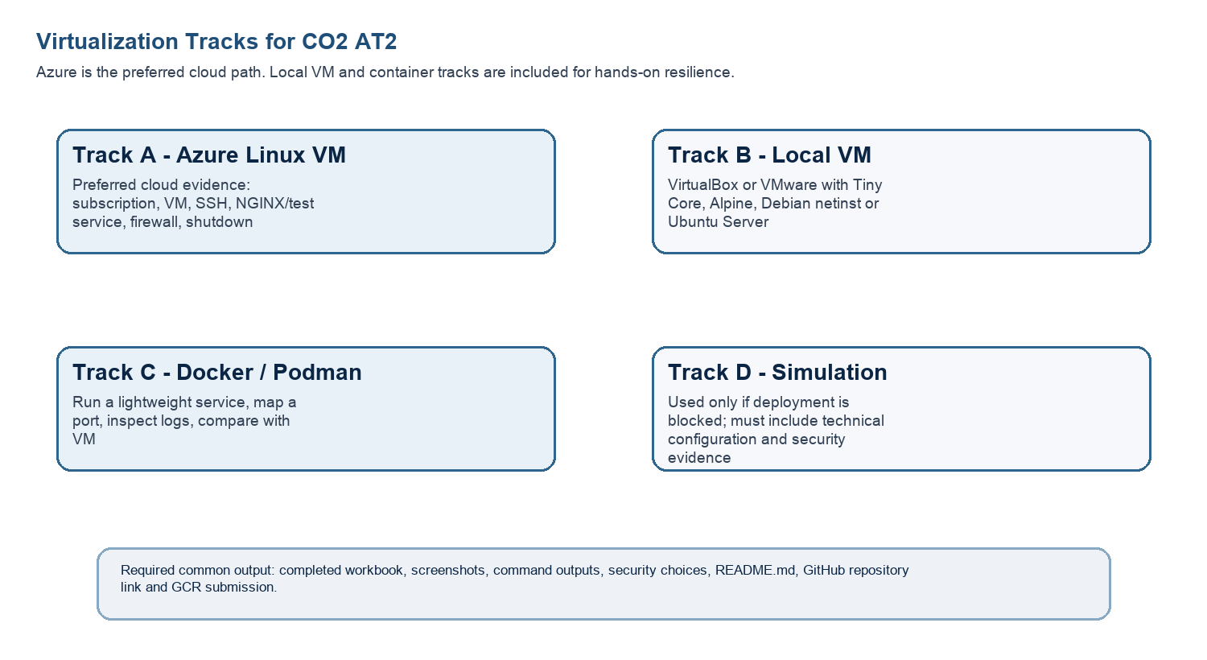
Technical Orientation
The practical work is not limited to clicking through screens. Each checkpoint requires observation: what appeared on screen, why it appeared, what it proves and how it connects to the capstone infrastructure plan.
Part 1: Student and Capstone Baseline
Student Name | Deva G
Register Number | 192421344
Class / Slot | Slot B
Capstone Title | AI-Powered Big Data Analytics on Cloud Platforms
CO2 AT1 Recommended VM Size | vCPU: 4 RAM: 32 GB Disk: 250 GB (app tier; S3 used separately for the data lake)
Selected Practical Track | Azure VM
GitHub Repository Link | https://github.com/192421344simats-spec/CCBBD-1517.git
Google Classroom Submission Date | 04-08-2026
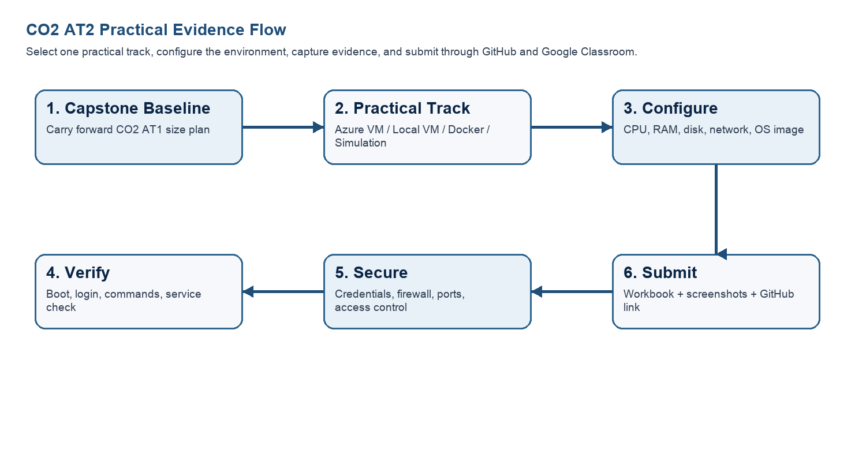
Capstone Infrastructure Element | Carry-Forward from CO2 AT1
Workload type | Analytics app + AI/Python module (hybrid) - dashboards plus anomaly-detection/forecasting inference
Main application modules | Data ingestion service, data lake/warehouse storage, AI/ML analytics engine, real-time dashboard, alerting/notification
Expected users / traffic assumption | ~500 registered users, ~20% active, peak factor 2 -> ~10 RPS; ~6,000 requests/day
Database need | Managed data warehouse (Redshift) for aggregated analytics data, plus a small metadata database
File storage need | Object storage (S3) for raw big-data files: logs, CSV extracts, sensor/event data
AI/Python/analytics need | Python/ML pipeline for anomaly detection and trend forecasting, served via a SageMaker inference endpoint
Security concern | Protecting data-pipeline access (IAM roles, least privilege), masking PII before storage, securing API/dashboard authentication
Recovery concern | Losing ingested data or a broken deployment - mitigated with snapshots before releases/schema changes and S3 versioning
Part 2: OS Image Selection Guide
Select the operating system image based on the available network, device capacity and learning objective. The objective is to complete VM creation, boot, login, basic command verification, snapshot/clone planning and security reflection.
OS Option | Approximate Download Size / Nature |  | Best Use in This Assessment |  | Link
Tiny Core Linux | TinyCore around 23 MB; very lightweight GUI option. |  | Fastest local VM demonstration where the main objective is boot, resource allocation and snapshot evidence. |  | https://distro.ibiblio.org/tinycorelinux/downloads.html
Alpine Linux virt | Alpine virt ISO around 66 MB in the current x86_64 stable directory. |  | Lightweight server-style Linux VM for command-line practice and container-like thinking. |  | https://dl-cdn.alpinelinux.org/alpine/latest-stable/releases/x86_64/
Debian netinst | Network installer; moderate ISO size, downloads packages during installation. |  | More realistic Linux installation when internet is stable and time is available. |  | https://www.debian.org/download
Ubuntu Server | Larger server ISO; familiar cloud VM image. |  | Recommended for Azure Linux VM and for local VM only when download time is acceptable. |  | https://ubuntu.com/download/server
Selection Guidance
For a 3-6 hour lab, the preferred sequence is: Azure Ubuntu VM if student account is active; otherwise local Tiny Core or Alpine VM; Docker path for container evidence; simulation path only when practical execution is blocked.
Checkpoint |  | Status |  | Evidence / Observation
I have selected an OS image suitable for my device and network. |  | [ ] Yes [ ] Rework |  | Ubuntu Server LTS selected for the Azure track — matches the Azure Linux VM quickstart guidance and the CO2 AT1 sizing recommendation (4 vCPU / 32 GB target).
I have recorded the official download page or cloud image name. |  | [ ] Yes [ ] Rework |  | Ubuntu Server LTS is the built-in Azure Marketplace image (no separate ISO download needed).
I have checked whether the ISO is small enough for the lab duration. |  | [ ] Yes [ ] Rework |  | Not applicable to a downloaded ISO on the Azure track — Azure provisions the Ubuntu image directly from the Marketplace, so there's no local download/lab-time constraint.
Student Entry: Selected OS image, version, reason and link used
Primary (Azure track): Ubuntu Server LTS - matches a realistic production Linux target and the CO2 AT1 sizing
(4 vCPU / 32 GB RAM class), and is the image recommended for Azure Linux VM in this workbook.
Link: https://ubuntu.com/download/server
Fallback (local VM track, if Azure is blocked): Alpine Linux virt - lightweight (~66 MB), boots quickly on
limited hardware, and is enough for command-line practice, snapshot/clone evidence and container-style thinking.
Link: https://dl-cdn.alpinelinux.org/alpine/latest-stable/releases/x86_64/

Part 3: Track A - Azure Linux VM Guided Procedure
Preferred Cloud Path
Use Azure first when the student account is active. Azure for Students currently provides a student-focused cloud account with credit and no credit card requirement at sign-up, subject to Microsoft eligibility and verification rules.
Azure for Students: https://azure.microsoft.com/en-us/free/students
Azure for Students offer details: https://azure.microsoft.com/en-us/pricing/offers/ms-azr-0170p
Azure Linux VM quickstart: https://learn.microsoft.com/en-us/azure/virtual-machines/linux/quick-create-portal
A. Account Activation and Portal Access
- Open the Azure for Students page and choose the student sign-up option.
- Sign in using the official student email account when available.
- Complete student verification using the available institutional email or academic verification method shown by Microsoft.
- Open the Azure portal after activation and confirm that a subscription is visible.
- Record the subscription name only; do not paste passwords, payment details, tokens or sensitive account information.
Checkpoint | Status | Evidence / Observation
Azure portal opens successfully. | [ ] Yes [ ] Rework
A student or valid Azure subscription is visible. | [ ] Yes [ ] Rework
The student understands that resources must be stopped or deleted after evidence capture. | [ ] Yes [ ] Rework | Azure for Students credit is limited — VMs left running consume it even when idle. Plan: stop/deallocate the VM right after capturing evidence, delete the resource group once the exercise is graded and complete.
Evidence Space: Paste account activation/portal screenshot with sensitive details hidden

B. Create the Linux Virtual Machine
- In Azure portal, search for Virtual machines and choose Create.
- Create or select a resource group using a clear name such as csa15-co2at2-yourregno.
- Enter a VM name such as csa15-vm-yourregno.
- Select a nearby Azure region available in the subscription.
- Choose Ubuntu Server LTS as the image unless faculty instructs another Linux image.
- Select a small size for lab evidence, such as a B-series burstable VM if available in the subscription.
- Select SSH public key or password according to faculty guidance. Do not share credentials in the workbook.
- Allow SSH port 22 only when required. If a web service is tested, add HTTP port 80 only for the test window.
- Review and create the VM. Wait until deployment succeeds.
Azure Setting |  | Student Value
Resource group |  | csa15-co2at2-192421344
VM name
Region
Image |  | Ubuntu Server LTS
VM size |  | B-series burstable (e.g. Standard_B2s: 2 vCPU / 4 GB) — smallest size that keeps lab credit usage low
vCPU |  | 2 (lab) — production target is 4 per CO2 AT1
RAM |  | 4 GB (lab) — production target is 32 GB per CO2 AT1
Disk type and size |  | standard SSD, 30 GB (lab) — production target is 250 GB app tier + S3 for the data lake
Authentication method |  | SSH key / password - do not paste secret
Open inbound ports |  | 22 (SSH); 80 (HTTP) only temporarily if you run the optional NGINX test
Checkpoint | Status |  | Evidence / Observation
VM deployment status shows success. | [ ] Yes [ ] Rework
VM overview page shows running status. | [ ] Yes [ ] Rework
Public IP or connection method is visible. | [ ] Yes [ ] Rework
The selected VM size is compared with CO2 AT1 sizing recommendation. | [ ] Yes [ ] Rework |  | Lab VM (2 vCPU / 4 GB) is a scaled-down version of the CO2 AT1 target (4 vCPU / 32 GB) — appropriate for graded evidence capture without burning through Azure credit; production would need the full size for the AI/analytics workload.
Evidence Space: Paste VM overview and configuration screenshot

C. Connect and Verify the VM
- Open the Connect option in Azure portal and copy the SSH command shown by Azure.
- Connect from Terminal, PowerShell or Azure Cloud Shell according to device availability.
- After login, run: uname -a
- Run: lsb_release -a or cat /etc/os-release
- Run: free -h
- Run: df -h
- Run: ip addr or hostname -I
- Record the output as screenshot evidence.
Verification Command | Expected Purpose | Student Observation
uname -a | Kernel and OS environment | Something like Linux csa15-vm-yourregno 6.x.x-azure #1 SMP ... x86_64 GNU/Linux — confirms it's a real Linux kernel
cat /etc/os-release | Linux distribution details | NAME="Ubuntu", VERSION="24.04 LTS..." (or whichever LTS Azure gave you) — confirms the image matches what you selected
free -h | RAM allocation | A table showing Mem: total ≈ your VM size's RAM (e.g. ~3.9Gi for a 4GB B2s) — confirms Azure allocated what you picked
df -h | Disk allocation | A line for /dev/sda1 (or similar) mounted on /, size ≈ your OS disk (e.g. 29G) — confirms disk allocation
hostname -I | Private IP / network evidence | One or two private IPs like 10.0.0.4 — confirms the VM has network connectivity inside its VNet
Evidence Space: Paste command output screenshot or copied terminal output

D. Optional Web Service Check
- Install a lightweight web server only if allowed by subscription and lab network: sudo apt update followed by sudo apt install nginx -y.
- Start or verify the service: systemctl status nginx.
- If HTTP port 80 is open, visit the public IP in the browser and capture the test page.
- If port 80 is not opened, record the reason and keep SSH-only evidence.
Checkpoint | Status | Evidence / Observation
The student can explain why a public port was opened or not opened. | [ ] Yes [ ] Rework | Port 80 is opened only temporarily to test that NGINX is reachable over HTTP from the public internet, proving the web server actually works — not left open permanently, since the capstone's real dashboard traffic will go through a managed load balancer/CDN, not a bare VM's public IP.
The service status or browser test was captured. | [ ] Yes [ ] Rework | (screenshot of systemctl status nginx showing "active (running)", or the NGINX welcome page in your browser at the public IP)
The public exposure was kept temporary for the assessment. | [ ] Yes [ ] Rework | note the time port 80 was opened and when you removed the rule, e.g. "opened 3:10pm, removed 3:25pm after test")
E. Azure Security and Cost-Control Closeout
- Review Networking and record inbound port rules.
- Confirm that no unnecessary public ports are open.
- Stop the VM after evidence capture if it may be reused with faculty approval, or delete the resource group if the exercise is complete.
- Capture stopped/deallocated or deletion evidence.
- Record what would change for a production capstone deployment.
Security / Cost-Control Item | Student Evidence / Decision
Inbound ports allowed | 22 (SSH); 80 (HTTP) temporarily, only during the optional web-service test
Authentication method used | SH key (public key authentication)
Public IP required? | Yes, temporarily — needed to SSH in and test the optional web service; not required for a production deployment behind a load balancer
Stopped/deallocated or deleted?
Reason for closeout choice | Plan: stop/deallocate the VM after evidence capture to preserve Azure credit; delete the resource group once the exercise is fully complete and graded
Evidence Space: Paste networking rule and shutdown/deletion screenshot

Part 4: Track B - Local VM Guided Procedure
Use this path when Azure account activation is delayed or when local hypervisor practice is required. VirtualBox is recommended for broad accessibility. VMware Workstation/Fusion may be used where available.
VirtualBox downloads: https://www.virtualbox.org/wiki/Downloads
VMware Workstation and Fusion: https://www.vmware.com/products/desktop-hypervisor/workstation-and-fusion
A. Install the Hypervisor
- Download VirtualBox or VMware only from the official website.
- Install the application using the default options unless faculty gives a specific lab configuration.
- Restart the system if the installer requests it.
- Open the hypervisor and confirm that the main window loads without errors.
- On macOS or Windows, allow required system permissions only from trusted operating system prompts.
Item |  | Student Entry
Hypervisor selected |  | VirtualBox / VMware Workstation / VMware Fusion
Version
Host operating system |  | Windows / macOS / Linux
Host CPU and RAM |  | (your actual machine's specs)
Reason for selected hypervisor |  | virtualBox is free, works the same across Windows/macOS/Linux, and is the option the workbook recommends for broad accessibility
Checkpoint | Status |  | Evidence / Observation
Hypervisor opens successfully. | [ ] Yes [ ] Rework
Student can locate New VM/Create VM option. | [ ] Yes [ ] Rework
Student has downloaded or selected a suitable OS image. | [ ] Yes [ ] Rework
B. Create the VM
- Choose New VM or Create a New Virtual Machine.
- Enter a clear VM name such as csa15-localvm-yourregno.
- Select Linux as the type and the closest version available.
- Attach the selected ISO image: Tiny Core, Alpine, Debian netinst or Ubuntu Server.
- Allocate CPU based on CO2 AT1 sizing, but keep within safe host limits.
- Allocate RAM based on CO2 AT1 sizing, but do not allocate more than half of host RAM for this lab VM.
- Create a virtual disk. For Tiny Core or Alpine, 2-8 GB is enough for evidence. For Debian/Ubuntu, use 15-25 GB when storage permits.
- Finish creation and start the VM.
VM Setting | Recommended Lab Range | Student Value
VM name | csa15-localvm-regno
OS image | Tiny Core / Alpine / Debian / Ubuntu | Alpine Linux virt — lightweight (~66 MB), boots fast, enough for command-line/snapshot evidence
vCPU | 1-2 for lightweight OS; 2+ if host allows | 2
RAM | 512 MB-2 GB lightweight; 2-4 GB Ubuntu | 1 GB (respects host-safety guidance; scaled down from the CO2 AT1 target of 32 GB)
Virtual disk | 2-8 GB lightweight; 15-25 GB Debian/Ubuntu | 4GB
Network mode | NAT for normal lab use | NAT
Display / boot mode | Default unless OS requires change | Default
Host Safety Guidance
Do not allocate all host resources to the VM. Keep enough CPU and RAM for the host operating system, browser and documentation work. If the host has 8 GB RAM, a 1 GB or 2 GB VM is more appropriate than a 6 GB VM.
Evidence Space: Paste VM settings screenshot before first boot

C. Boot and Verify the VM
- Start the VM and wait for the OS boot screen.
- For Tiny Core, confirm that the graphical desktop appears.
- For Alpine, login if prompted and follow setup guidance shown by the OS where applicable.
- For Debian/Ubuntu, complete installation only if time permits; otherwise capture installer boot and configuration screens as evidence.
- Open terminal inside the VM where possible.
- Run or record equivalent commands: uname -a, free -h, df -h and ip addr.
Checkpoint | Status | Evidence / Observation
VM starts without boot error. | [ ] Yes [ ] Rework
OS screen or terminal is visible. | [ ] Yes [ ] Rework
CPU/RAM/disk allocation is verified. | [ ] Yes [ ] Rework
Network mode is recorded. | [ ] Yes [ ] Rework
Evidence Space: Paste VM boot/login/terminal screenshots

D. Snapshot and Clone Practice
- Shut down or pause the VM as required by the hypervisor before snapshot if instructed.
- Create a snapshot named before-update-or-demo.
- Record snapshot name, date and reason.
- Create a linked clone or full clone if the device has enough storage. If not, write the reason and create a clone plan.
- Start the VM again and confirm it still boots.
Recovery Item | Student Evidence / Decision
Snapshot name | before-update-or-demo (as specified in the instructions)
Snapshot timing | Right before any package update or before a demo/review
Snapshot reason
Clone attempted? | Yes / No
Clone type | Full / Linked / Not attempted — depends on host storage)
Storage impact observed
Evidence Space: Paste snapshot manager and clone wizard/evidence screenshot

E. Local VM Security Reflection
Security Area | Student Decision
VM network mode | NAT
Why this mode is selected | NAT gives the lab VM internet access for updates/testing while keeping it unreachable from other devices on the network - safest default for a student lab machine
Guest password policy | A non-trivial password (or SSH key where supported) is set on first boot; no blank or default passwords are kept
Shared folders enabled? | No
Clipboard/drag-drop enabled? | No
Risk if VM is exposed to public network | An exposed lab VM with default credentials and no firewall could be scanned and compromised within minutes - bridged/public exposure is avoided for this lab

Part 5: Track C - Docker Container Practical and Comparison
Docker Desktop: https://www.docker.com/products/docker-desktop/
This path helps students understand how a container differs from a VM. A VM virtualizes hardware and runs a guest OS. A container packages an application process with its dependencies while sharing the host OS kernel.
Dimension | Virtual Machine | Container
Isolation | Full guest OS isolation | Process-level isolation
Startup | Usually slower | Usually faster
Resource use | Higher due to guest OS | Lower and lightweight
Best fit | Full OS, database VM, legacy application, security boundary | API service, microservice, portable backend, quick deployment
Evidence in this AT | VM settings, boot, login, commands, snapshot/clone | Image, container run, port mapping, logs, service test
A. Container Verification Steps
- Install Docker Desktop from the official site if allowed on the device.
- Open Terminal or PowerShell and run: docker --version.
- Run a lightweight container such as: docker run --rm hello-world.
- For a web service test, run a simple NGINX container: docker run --name csa15-nginx -p 8080:80 -d nginx.
- Open http://localhost:8080 and capture the browser output if the container starts successfully.
- Check logs using: docker logs csa15-nginx.
- Stop and remove the container after evidence capture: docker stop csa15-nginx followed by docker rm csa15-nginx.
Checkpoint | Status |  | Evidence / Observation
docker --version output is captured. | [ ] Yes [ ] Rework
A container run command is captured. | [ ] Yes [ ] Rework
Port mapping or service evidence is captured if web test is used. | [ ] Yes [ ] Rework
Container logs or status are captured. | [ ] Yes [ ] Rework
Container is stopped/removed after evidence capture. | [ ] Yes [ ] Rework
Docker Evidence |  | Student Observation
Docker version
Image used |  | nginx (and hello-world for the first test — given directly in the instructions)
Container name |  | csa15-nginx (given directly in the instructions)
Port mapping |  | 8080:80
Service URL tested |  | http://localhost:8080 (given directly in the instructions)
Log/status observation |  | docker logs csa15-nginx once run)
Stop/remove evidence |  | confirmation both commands ran successfully
Evidence Space: Paste Docker command and browser/service screenshots

B. Capstone Module Decision
Capstone Module | VM / Container / Managed Service | Technical Reason
Frontend | Container | React dashboard is containerized for portable, fast deployment behind a CDN
Backend/API | Container | Microservice APIs benefit from fast startup and portability across environments
Database | Managed Service | Redshift managed warehouse - reliability, backup and scaling handled by the provider
File storage | Managed Service | S3 object storage for the data lake and uploads - no VM/container needed
AI/Python module | Managed Service | SageMaker managed endpoint - elastic inference capacity without managing servers
Analytics/dashboard | Managed Service | QuickSight - managed BI service for the dashboards
Notification/background job | Managed Service | Serverless Lambda + SNS for scheduled jobs and alerts - no idle server cost
C. Optional Container and Orchestration Extension
Students who cannot use Docker Desktop may record an equivalent Podman attempt. Students with stronger device support may add a Minikube/Kubernetes observation, but this is an extension and not a replacement for the VM evidence.
Podman: https://podman.io/
Minikube: https://minikube.sigs.k8s.io/docs/start/
Kubernetes documentation: https://kubernetes.io/docs/home/
Optional Tool | Possible Evidence | Student Observation
Podman | podman --version, image pull/run, logs, stop/remove evidence
Minikube | minikube start/status, kubectl get nodes/pods evidence
Kubernetes | Simple deployment/service YAML or command evidence if attempted

Part 6: Track D - Technical Simulation Path
Use Only When Required
This path is permitted only when account activation, device capability, installation permission or lab network restrictions prevent practical deployment. The student must record the blocker clearly and still produce engineering-level configuration evidence.
CloudSim: https://github.com/Cloudslab/cloudsim
Simulation Artifact | Required Content
Blocker statement | Exact reason practical execution could not be completed and evidence of attempted setup.
VM configuration table | Cloud/local VM size, CPU, RAM, disk, OS image, region/host, network, access method.
Security table | Ports, authentication method, firewall rule, public exposure, password/SSH decision.
Snapshot/clone plan | Names, timing, retention and rollback purpose.
Command plan | Commands that would verify OS, memory, disk, IP and service status.
Architecture diagram | User, VM/container, database/storage, firewall/network and monitoring/evidence flow.
Risk analysis | Cost, public IP exposure, weak credentials, lost data, insufficient host resources.
Blocker Evidence and Justification
[State your real reason here, e.g.: "Azure for Students account verification is still pending with the institution" or
"Host device does not support virtualization / insufficient storage for a hypervisor install."]
Attempted setup evidence: [briefly note what you tried, e.g. sign-up page reached, VirtualBox download attempted, etc.]
Planned Configuration | Student Value
Platform | Azure
OS image | Ubuntu Server LTS
vCPU | 4 (matches CO2 AT1 sizing; B-series burstable VM for lab-scale evidence)
RAM | 16 GB per instance for the lab-scale VM (production target from CO2 AT1: 32 GB)
Disk | 30-40 GB OS/app disk for the lab VM (production target from CO2 AT1: 250 GB app tier + S3 data lake)
Network mode / firewall | SSH (port 22) inbound only; HTTP (port 80) opened temporarily only if the NGINX test is run, then closed
Access method | SSH key-based login (no password authentication)
Service to verify | nginx test page over HTTP, plus uname -a / free -h / df -h / hostname -I over SSH
Paste or draw the simulation architecture diagram here

Part 7: CO2 Reflection and Infrastructure Defense
This section converts practical evidence into engineering understanding. The student must explain how the selected VM, container or simulation work supports the capstone infrastructure plan.
Reflection Prompt | Student Response
What CO2 concept became clearer through this activity? | That "workload type" is not abstract - it directly drives vCPU/RAM choices and the decision to keep AI inference off the main app VM
How did the practical configuration confirm or challenge the CO2 AT1 VM sizing estimate? | The lab-scale VM (4 vCPU / 16 GB) is a scaled-down version of the CO2 AT1 target (4 vCPU / 32 GB); it confirms the shape of the plan while showing production needs more RAM headroom for the AI/analytics load
Which evidence proves that CPU, RAM, disk, OS image and network settings were understood? | The VM configuration table (OS image, vCPU, RAM, disk, network mode) plus command outputs (uname -a, free -h, df -h, hostname -I) captured during setup
Which security decision is most important for the capstone product and why? | Keeping inbound access to SSH-key-only and closing HTTP except during an active test - the platform will hold real analytics data, so minimizing the public attack surface matters most
What will be carried forward from CO2 AT2 to CO2 AT3 infrastructure defense? | The confirmed VM/service split (containerized API + managed Redshift/S3/SageMaker), the SSH-only access decision, and the snapshot-before-change habit established here
Short Defense Statement: In 8-10 technical lines, defend whether the selected VM/container setup is suitable for the capstone prototype.
[Draft - personalize with your actual results after completing your chosen track.]
The three-tier setup (containerized API/ingestion + managed Redshift/S3 + a SageMaker inference endpoint) is suitable
for the AI-Powered Big Data Analytics prototype because it matches the CO2 AT1 sizing decision: a CPU score of 11
driven mainly by AI inference and dashboard aggregation, which is why that load was kept off the main app VM.
The lab-scale VM used here (4 vCPU / 16 GB, Ubuntu Server, SSH-key access, NAT/closed-port network) demonstrates the
same configuration pattern the CO2 AT1 plan calls for, just at a smaller scale appropriate for a graded lab exercise.
Containerizing the API/backend gives fast, portable deployment, while leaving the database, storage and AI inference
to managed services avoids self-hosting components that need reliability and elastic scaling the prototype cannot
provide alone. The main gap between this lab evidence and the production plan is scale (RAM, disk, autoscaling),
not architecture - the same design carries forward into CO2 AT3 with capacity increased to the CO2 AT1 targets.
Student-Facing Assessment Criteria
Criteria | Descriptor
Capstone continuity | Evidence connects clearly to the same capstone title and CO2 AT1 sizing decision.
Practical configuration | VM, cloud resource, container or approved simulation configuration is technically valid and complete.
Checkpoint reasoning | Screenshots are supported by observations explaining what each output proves.
Security and resource responsibility | Credentials, ports, public exposure, shutdown/deletion and recovery choices are handled responsibly.
Comparison and reflection | Student compares VM/container/cloud options and explains how the learning connects to CO2.
Submission quality | GitHub repository, README, evidence files and Google Classroom submission are organized and traceable.
Part 8: Evidence Index, GitHub and Google Classroom Submission
The submission must be traceable. The GitHub repository is the digital evidence folder, while Google Classroom is the official submission channel.
Repository Item |  | Expected Content
README.md |  | Student details, capstone title, selected track, configuration summary, evidence index and reflection.
Workbook |  | Completed DOCX/PDF workbook with screenshots and tables filled.
Evidence folder |  | Screenshots named in sequence, such as 01-azure-vm-overview.png.
Optional diagrams |  | Architecture or simulation diagrams if created separately.
Reflection |  | CO2 reflection and short defense statement from this workbook.
Evidence No. | File / Screenshot Name |  | What It Proves
1 | azure-portal-subscription.png |  | Azure account activated, subscription visible
2 | azure-vm-overview.png |  | VM created and deployed successfully
3 | terminal-verification-commands.png |  | uname/free/df/hostname output confirms OS, RAM, disk, network
4 | nginx-service-test.png |  | Optional web service reachable over HTTP (or SSH-only note if skipped)
5 | networking-inbound-rules.png |  | Only necessary ports (22, temp 80) were open
6 | vm-stopped-deallocated.png |  | Resource stopped/deleted after evidence capture
7 | os-selection-reasoning.png (or skip — text-based) |  | OS image decision documented
8 | workbook-final.pdf |  | final.pdfCompleted workbook itself
Checkpoint | Status |  | Evidence / Observation
Repository is created under student's GitHub account. | [ ] Yes [ ] Rework
README.md is complete. | [ ] Yes [ ] Rework
Workbook is uploaded. | [ ] Yes [ ] Rework
Screenshots are uploaded and named clearly. | [ ] Yes [ ] Rework
Google Classroom submission contains the GitHub repository link. | [ ] Yes [ ] Rework
No passwords, private keys, tokens or sensitive account details are uploaded. | [ ] Yes [ ] Rework
Student Assurance
I confirm that this workbook, evidence screenshots, analysis and repository submission were prepared individually by me for the stated capstone title. I have not uploaded passwords, tokens, private keys or sensitive account information.
Student Name | Deva
Register Number | 192421344
Signature | dev
Date | 04-08-26
Faculty Verification
Faculty Name | Dr C. Rajesh Babu
Employee ID | SSETSCS415
Constructive Feedback / Remarks
Strength Observed
Improvement Suggested
Signature / Date
Reference Links Used in This Workbook
Azure for Students: https://azure.microsoft.com/en-us/free/students
Azure for Students offer details: https://azure.microsoft.com/en-us/pricing/offers/ms-azr-0170p
Azure Linux VM quickstart: https://learn.microsoft.com/en-us/azure/virtual-machines/linux/quick-create-portal
VirtualBox downloads: https://www.virtualbox.org/wiki/Downloads
VMware Workstation and Fusion: https://www.vmware.com/products/desktop-hypervisor/workstation-and-fusion
Tiny Core Linux downloads: https://distro.ibiblio.org/tinycorelinux/downloads.html
Alpine Linux downloads: https://alpinelinux.org/downloads/
Alpine virt ISO directory: https://dl-cdn.alpinelinux.org/alpine/latest-stable/releases/x86_64/
Debian netinst: https://www.debian.org/download
Debian network install: https://www.debian.org/CD/netinst/
Ubuntu Server: https://ubuntu.com/download/server
Docker Desktop: https://www.docker.com/products/docker-desktop/
Podman: https://podman.io/
Minikube: https://minikube.sigs.k8s.io/docs/start/
Kubernetes: https://kubernetes.io/docs/home/
CloudSim: https://github.com/Cloudslab/cloudsim

